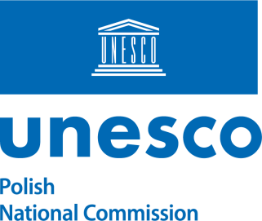 | 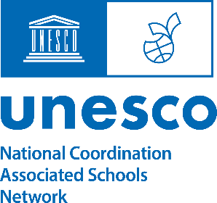 | 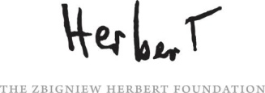

Invitation to participate in the “Gift a Poem” campaign
on World Poetry Day March 21st

For the second time, the Polish National Commission for UNESCO, ASPnet Poland and the Zbigniew Herbert Foundation, in cooperation with the ASPnet International Coordination Unit are inviting member schools around the world to organize “Gift a Poem” campaign as a form of commemoration of World Poetry Day on 21 March 2024.

As a reminder, the 2023 'Gift a Poem' campaign was conducted as a joint ASPnet activity as part of the celebration of the UNESCO Associated Schools Network 70th anniversary. The campaign was very well received and a great success. Reports were sent from 14 countries on four continents and are available at www.giftapoem.pl.

Many countries have expressed interest in holding the Gift a Poem campaign again in 2024. This year has been declared by UNESCO as the year to celebrate the centenary of the Polish poet Zbigniew Herbert. The poet whose gesture inspired the Gift a Poem campaign: Herbert offered handwritten Poem Letters to his friends, artists, and people important to him.

We believe that the act of offering someone words of poetry is a thoroughly human one: a form of friendly co-presence, spiritual support, of consolation as well as a means of sustaining hope and building peace. That is why we wish to encourage students participating in this initiative to find someone and gift that person a poem. Not only to people in their closest circle (family, friends, neighbours and acquaintances), but also in places where a good word is so often needed – in nursing homes, retirement homes, orphanages, community centers, homeless shelters, hospitals, etc.

We invite all schools to participate in a simple, yet meaningful activity, which can be summed up in four simple steps:

1. Choose a book of poetry (at home or at school)
2. Select a poem
3. Copy the chosen poem by hand onto a stationary card specially prepared by us (a ready-to-print pdf will be available)
4. Gift the copied poem to someone specific

On 12 February at 3 p.m. CET, all ASPnet National Coordinators are invited to participate in a webinar, during which the organizers of the campaign will explain all organizational details of the "Gift a Poem" website and relevant materials. They will recall the course of the 2023 campaign and introduce the profile of the poet Zbigniew Herbert, whose birth centenary is being celebrated by UNESCO.

To participate in the webinar, please register at the following link:

https://forms.office.com/e/3X3cDcwBeL

Thus, participating in the “Gift a Poem” initiative could become a “lesson
in compassion”, as well as an opportunity to build intergenerational relationships,
to show selfless empathy towards the needy, abandoned, lonely. In short,
to build peace.

Małgorzata Herbich Maria Dzieduszycka
Polish ASPnet National Coordinator President/Executive Director
Polish National Commission for UNESCO The Zbigniew Herbert Foundation
e-mail: m.herbich@unesco.pl

